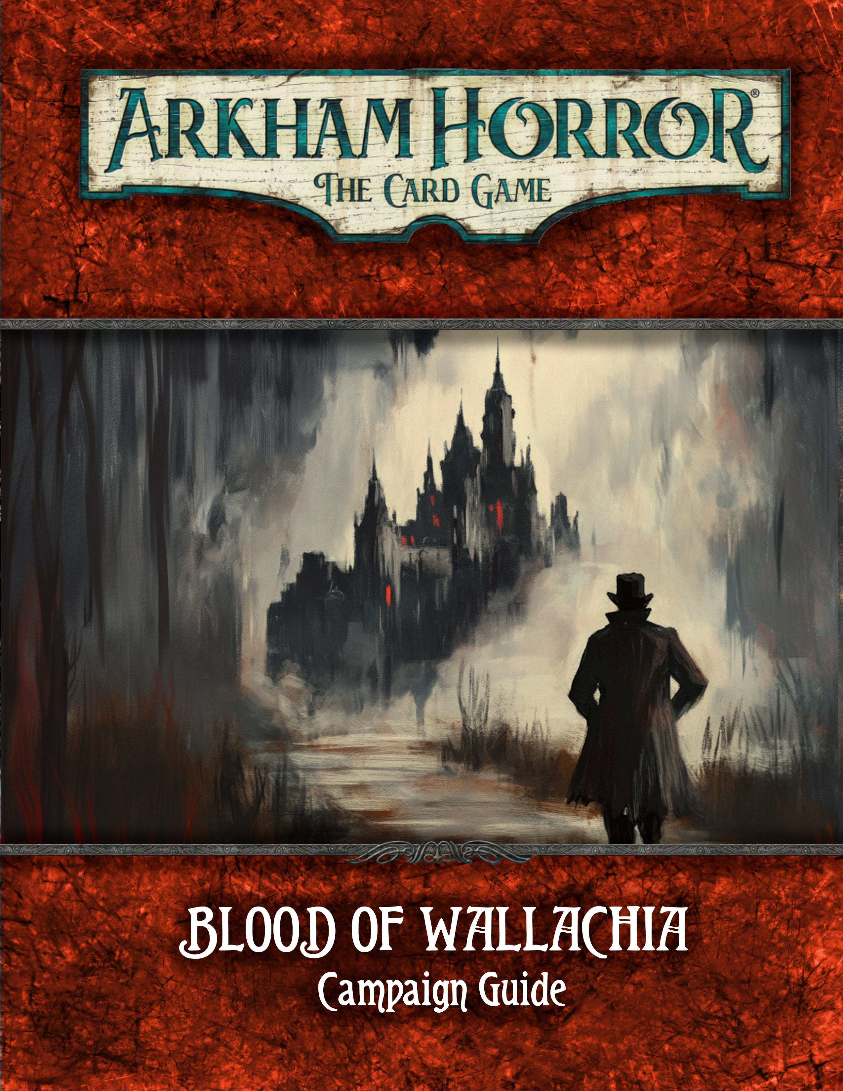

Evil Rises Again
In this time of peace and plenty, no-one foresees the return of ancient horrors...
But the old legends live, and soon the land will again be plunged into darkness. The people have returned to the path of wickedness. And the bonds that seal their evil rulers spirit are weakening. Deep in his castle he stirs from a century of enforced sleep.
- Castlevania

Blood of Walachia is a fan created campaign for Arkham Horror: The Card Game for 1-4 players. Blood of Walachia contains 8 scenarios (list scenarios).
Contents
Evil Rises Again 2
New Gameplay 2
Additional Rules and Clarifications 2
Prologue 5
Scenario I: Shadows in the Village 6
Interlude I – The Rescue 8
Scenario: The Lost Woods 9
Scenario: Shadows in the Mist 10
Scenario: The Monestary 11
Scenario: The Vila 12
Scenario VI: The Farm 13
Scenario VII: Ladders and Snakes 14
Scenario VIII: Bloody Tears 15
Enemy: Dario 16
Enemy: Lucia 17
Enemy: Ludvig 18
Enemy: Sophia 19
Enemy: Carmilla 20
Game Design 21
Designer notes 21

New Gameplay
Blood of Walachia is designed with a slightly different mindset than other campaigns, both official and fan made, in Arkham Horror. There’s an attempt at a more fluid difficulty level, and slightly more explorative game play. If you want to learn more about what this means, look at the section “Game Design” on page 21 guide to read what to expect. This won’t spoil any story elements, but it might help you avoid feeling like you’re running head first into a wall.
If you prefer to just experience the game as is, and figure out what’s expected of you by failing, then by all means – you’re the reason we put the design notes in the back, after all.
Unsure if you should you read that entry? Here’s a couple of questions to help you determine that. If your answer is a clear yes to 1 or more questions, you probably should:
- Do you prefer to have a good chance at winning a campaign the first time you play it?
- Is Arkham Horror more about the gameplay than the narrative?
- Does it feel cheap if the campaign changes core expectations, like “gathering clues leads to winning”, without telling you?
- Do you find that Arkham Horror is usually a hard game, that you rarely win?
If you answered “no” to all of these, you’re probably good to go. Otherwise, we’ll see you back here in 3 minutes.

Additional Rules and Clarifications

Day, Night and the Calendar
Blood of Wallachia uses a calendar, and a day and night system. During each scenario, either the agenda or the act will be tied to the day and night cycle.
When relevant, one will be marked with "Day" or "Night". When you switch from day to night or vice versa, remember to mark it in your campaign log. You will also be reminded to do so by the scenario itself. If at any time you need to check which date or day/night it is, check the calendar in the campaign log: "Current" is the first box that you haven't checked off.
Most of the scenarios will never end, and instead loop continuously, allowing you to keep playing the same scenario until you feel that you're done. If you want to find a happy ending to the story however, you might want to push yourself and avoid wasting time.

Templating language and Traits
A couple of new template choices is being used throughout Blood of Wallachia, both to use a more natural language and to spend less card space on easily understood game mechanics.
“Test X to...”
The very common template "Test <skill> (<difficulty>). If you succeed..." now has a short hand version.
"Test w(3). If you're successful, evade this enemy" could now be written as "Test w(3) to evade this enemy.". They are functionally identical.
“Test X to not...”
The inverse case, "Test <skill> (<difficulty>). If you fail..." also has a short hand version.
"Test w(3). If you fail take 3 horror" can now be written as "Test w(3) to not take 3 horror.".
The longer, more verbose version, will still be in use in complex cases to avoid confusion. For example: “Test w(3). If you succed draw 2 cards. If you fail, take 1 horror for each point you failed by.” won’t appear in a short hand form.
Why not use the more natural sounding"Test Skill (x) or..."? Because that could lead to confusion as to whether there's a choice to be made.

“Place one X token on ...”
Cards may reference token types without explicitly declaring that you should use resource tokens as markers. Whenever you’re instructed to place a “something” on a card, it’s a token of that type unless the scenario has specified otherwise. For example “Place one Book token on this location” is equivalent to “Place one resource token on this location as a Book.”
Tokens of the same name are the same type, for instance, a hyphothetical “Place one Ammo token” effect, would create the same type of token as “Uses (Ammo)” refer to.
“Search you deck for a trait”
Cards may refer to other cards by their traits in a natural form, singular or plural, and without specifying which card type is required.
For example, a card that previously would read “Search the top 9 cards of your deck for an item card” could now simply read “Search the top 9 cards of your deck for an item”.
If an effect doesn’t specify which card type it looks for, all card types are elligable. “Item” could refer to assets, weaknesses, events (see the card “Raven’s Quill”), etc. But usually traits are limited to a single card type – Items are almost always assets, Insights are events, Improvised are skills, etc. Which is exactly the reason why we felt that the short hand form was just as concise, while more flavorful to read.
Effects that do specify the card type must still be resolved according to the types specified, of course.

Sleep and Safe locations
Sleep is a new action type used throughout the campaign. It’s important to remember that it has an associated basic action. You do not need a card ability to sleep. After taking a Sleep action, you’re sleeping until you wake up.
The primary benefit of sleep, is to skip the nights in Wallachia. Those who stay up late will eventually get tired. They’ll also stumble upon the things that goes bump in the night.
Whenever you’re at a safe location at night, you can go to sleep. You can also sleep at non-safe locations if so instructed, or even be forced to. You cannot go to sleep, nor be sleeping during the day.
While sleeping, you cannot perform actions, or make choices. You perform one last upkeep during the upkeep phase, but no more than 1 upkeep per sleep (the first one, there’s no choice involved). You do not draw cards during the mythos phase while sleeping.
If you happen to take damage while sleeping, you wake up. This can happen due to engaged enemies attacking you, treacheries triggering, or even other player effects.
If all investigators are asleep, the following happens:
- Finish the round as normal. This usually means: End the current turn (a sleeping investigator can take no actions, even fast actions.). Resolve the enemy phase. Resolve the upkeep phase.
- During the mythos phase, advance the agenda as if it had the prerequisite number of doom on it.
- Players who fell asleep before the third round of the night, “slept through the night”. That is, if you’re awake while the third regular doom was placed on the agenda, you didn’t “sleep through the night”. This has no inherent effect, but most agendas will punish those who didn’t get enough sleep. Players who went to sleep, but woke up during the late night, also did not sleep through the night.
- After advancing the agenda to Day, regardless of how, all sleeping investigators “wake up” and resume playing as normal. This happens before drawing mythos cards, such that the first “action” will be to draw an encounter card from the Day deck. (More about that later)

New icons
A few new icons are being used on cards.
hd
These are the icons for damage and horror respectively. They can appear in a couple of ways. Either as a literal collection of icons, each accounting for 1 damage or horror, like so: “Take hhd”, being the same as “Take two damage and one horror”, or with a number in front
“Take 2 h and 1d”, again being the same as the previous example.
The last version is the following: “Take 3 h/d”, meaning “Take damage and/or horror in any combination totalling 3.” (If we intend it to mean “3 damage or 3 horror” we would write “Take 3 h or 3 d”)
m
This is the resource icon. This will always signify resources, and never other types of counters or markers that might be represented by the same tokens (eg. charges, ammo, secrets, etc).
#
This is the Codex icon, or text entry icon. This will always be accompanied by some identifier, such as “# 4” and means that you should read the matching text entry in the campaign book when you resolve the effect.
In Blood Of Wallachia, codex entries are provided for each scenario and can only be resolved once unless otherwise stated.

Insight and Leads
This campaign makes use of Insight and Leads. Insight represent your evidence and knowledge of the cults plans and intentions. Leads are the concrete whereabout of the various cult members and their weaknesses.
Like Victory, enemies with Insight or Leads are place in the victory display when defeated, and locations with either are counted when the game ends, if they have no clues on them.

Night Deck
Most scenarios will make use of two seperate encounter decks. A Night Deck and a Day Deck. During night, treat the Night Deck as the encounter deck.
If you would draw a card from an empty Night Deck, draw from the Day Deck instead.
There’s only a single discard pile for both decks, which means that all cards would eventually shuffle into the Day Deck, if the game went on long enough.

Setup checklist
Most setup instructions now feature a “checklist” point. This is purely to help you confirm that you’ve done everything correctly, not missed any steps and not misunderstood any instructions. The checklist is never an instruction for you to do something.
Expansion Icon
The cards in the Blood of Walachia campaign expansion can be identified by this symbol before each cards’s collector number:

Campaign Setup
To set up the Blood of Walachia campaign, perform the following steps in order.
1. Choose investigator(s).
2. Each player assembles his or her investigator deck.
3. Choose difficulty level.
4. Assemble the campaign chaos bag.
5. Regardless of difficulty level:
+1, 0, 0, -1, -1, -2, -2, -3, -4, S, S, S, T, E.
You're ready to begin at the Prologue.

Prologue
The International Criminal Police Commission headquarters in Berlin bustles with activity as you make your way to the briefing room. It's November 2nd, 1928, and the fledgling organization is abuzz with reports from across Europe. As you enter, conversations hush, and all eyes turn to you.
Kommissar Heinrich Schreiber, a stern man with a neatly trimmed mustache, gestures for you to take a seat. "We have a situation in Romania," he begins, his voice grave. "A remote village called Hunedoara. Eight young girls vanished in a single night last week."
You go over the case, but it’s a short affair, as nothing much is known yet.
As you rise to leave, Schreiber adds, almost as an afterthought, "And be careful. Wallachia has a... history. Don't let local superstitions interfere with your investigation."
If you playing on Hard or Expert continue to Prologue 1, otherwise skip to Prologue 2.
Prologue 1: Due to maintainance the train is delayed. You won’t be able to leave for another 2 days.
Cross of 2 days in the calendar in the campaign log. (4 marks)
Continue to Prologue 2.
Prologue 2: The rhythmic clatter of the train fills your ears as you watch the German countryside give way to the wilder landscapes of Eastern Europe. Despite the calming dark snow landscape outside the train, all you can focus on is the insessent rythm of the tracks. You make your way to the dining car, hoping a hot meal will help take your mind off the constant noise. The car is nearly empty, save for an elderly woman seated alone at a table, her eyes fixed on you as you enter.
She's clearly of Romani descent, her wrinkled face framed by a colorful headscarf. Silver bangles jingle softly on her wrists as she beckons you over with a gnarled hand.
"Come, come," she says in accented German. "Baba Zorica knows why you travel east. Sit, let old Zorica give you guidance."
There's something unsettling about her gaze, a glint of hidden knowledge that sets you on edge. Yet, you find yourself drawn to her table almost against your will.
"Danger awaits in the land of The Dragon," she murmurs, producing a set of worn tarot cards. "But Zorica can help. For a small price, she can grant you her blessing. Protection against the dark forces that gather."
You hesitate, weighing your options. There's no denying the old woman has an aura of mystical power about her. But is it wise to trust a stranger met on a train, especially one who seems to know more than she should?
The investigators decide (choose one):
- Pay Baba Zorica for her blessings. Proceed to Prologue 3.
- Politely decline her offer Proceed to Prologue 4.
Prologue 3: You pay the old lady. She mutters a few words in romani, then says "The light! Always stay in the light. The darkness holds nothing but loss for you."
You start next scenario with 1 fewer resources. Add C to the chaos bag. Skip to Prologue 5.
Prologue 4: "No thanks." The words have barely left your mouth before the old lady mutters a curse in romani. She then looks straight at you: "The darkness holds nothing but loss for you. And it will come for you!"
Add A to the chaos bag. Proceed to Prologue 4.
Prologue 5: The chill of early November bites at your skin as you step off the train onto the platform of a small Romanian station.
Your destination, Hunedoara, in the heart of what was once called Wallachia, is still a good while away.
The case seemed straightforward when you left Berlin, but as you hire a car for the final leg of your journey, a sense of unease settles over you.
As your hired vehicle rumbles down the winding road towards Hunedoara, you brief your companions on the situation. The dense forests pressing in on either side seem to watch your progress, their branches reaching out like gnarled fingers in the fading afternoon light.
Night has almost fallen by the time you reach the village outskirts. The scattered lights of Hunedoara offer little comfort as you make your way towards the center of town. You expected to be greeted by concerned citizens, eager for news of their missing children. Instead, you find empty streets and shuttered windows.
The few villagers you encounter hurry away at the sight of you, fear evident in their eyes. It's as if your very presence is an ill omen.
You find yourself a room at the local hotel.

Scenario I: Shadows in the Village
The weak autumn sun barely penetrates the grimy window of your rented room as you rise, the floorboards creaking ominously beneath your feet. The events of the previous day weigh heavily on your mind as you prepare to begin your investigation in earnest.
Your first order of business: Talk to the families of the missing children. As you step out into the chill morning air, the village of Hunedoara seems to bustle into new life, leaving no trace of the empty streets seen yesterday.
As you make your way to the village square, the weight of the mystery settles upon your shoulders. Eight young lives hang in the balance, and the clock is ticking. Whatever dark force has taken root in Hunedoara?
Setup
B Gather the Shadows in the Village encounter set. This set is indicated by the following icons:

B Find Carmilla in the Characters encounter set, and the entire Bats encounter set, and set them aside out of play. These sets are indicated by the following icons:

B Put each location into play. Each investigator start at either the Raven Hotel or the Village Square, but at least 1 investigator must start at the Village Square.
B Set the following cards aside, out of play: Concierge Stephania, Nurse Nikita.
B Split the rest of the encounter cards into Day and Night decks, and shuffle each deck.
B Checklist: 9 cards set aside out of play. 14 locations in play. 3 locations not connected to the rest. Investigators at the town square and possibly the hotel. 25 cards in Night Encounter Deck. 25 cards in Day Encounter Deck.
You are now ready to begin.

# Codex 1: The Church
If it’s day:
The inside of the church looks more like a refuge than a house of worship. There’s sleeping bags on the floor and small tents and makeshift wall. Near the main doors are heavy fortifications. Looks like whoever has been camping here are afraid of visitors.
Any investigator may read this entry again while on the Church during night.
If it’s night:
A bunch of people are camping in here. They’ve brought sleeping bags, small tents and makeshift privacy walls made out of blankts. The main doors have been heavily fortified by wooden bars and a couple of book shelves. Looks like visitors are not welcome.
The priest show you how to get here unseen if you ever need a safe place to hide. Reveal the South Tunnel if it’s unrevealed.
# Codex 2: Hospital
An nurse mentions an increase in injuries lately. People showing up with bruises, fractured bones, burn marks. Maybe he knows more than he’s letting on?
Put the set aside Nikita asset into play at The Hospital.
# Codex 3: The Ionescus
After some convincing that you are indeed trying to help, Marta and Jonas Ionescus tells you a about their daughters disappearance. They also show you an entrance to the secret tunnels under the village, in case you need a way to travel the village at night.
Revel the North Tunnel if it’s unrevealed.
# Codex 4: North Tunnel
After some searching, you find exits to the village.
The North Tunnel is connected to Ionescu’s Home and Raven Hotel until the end of the game.
# Codex 5: Central Tunnel
After some searching, you find exits to the village.
The Center Tunnel is connected to Town Square until the end of the game.
# Codex 6: South Tunnel
After some searching, you find exits to the village.
The South Tunnel is connected to Post Office and Church until the end of the game.

# Codex 7: The Raven Hotel
You spend some time talking to the staff, asking around. Especially the Conceierge, Stephania opens op to you. It turns out that she haven’t lived here long enough to take on the almost paranoid nature that most of the townspeople seem to share. “People are just afraid. The nights are terrifying out here. Even more so during the cold and dark seasons. And lately, these hooded figures have been seen roaming around. Anyway, let me know if I can help you with anything. I highly suggest you get a map of the town if you haven’t been here before.”
Put the set aside Stephania asset into play at Raven Hotel.
# Codex 8: Nikita
Nikita tells you about how nightly attacks occur in the village. Every day more people goes missing.
Add Nikita to the victory display.


DO NOT READ
until end of scenario
If there’s currently 3 or more doom on the Agenda, add 1 checkmark to the calendar.
If all investigators were defeated, proceed to Resolution 1.
Resolution 1: Times up. Even though you’ve suffered some defeats, you know you can’t just mope around and wait for everything to get better. Working with what you have, you decide to set out. You might be unprepared and your leads might not be the best, but those girls can’t wait anymore.
B Put two checkboxes in the calendar, then proceed to resolution 5.
Resolution 2: Some text goes here
B If some investigators where defeated proceed to Resolution 3. Otherwise, proceed to resolution 4.
Resolution 3:
B Some of your party wasn’t ready, so you need to hang back for a while, waiting for them to recover enough to travel.
Mark 1 checkbox in the calendar.
B Proceed to Resolution 4.
Resolution 4:
This is as good as it’s gonna get. The girls can’t wait anymore, time to move on.
Proceed to Resolution 5.
Resolution 5:
B Each investigator earns experience equal to the Victory X value of each card in the victory display.
Easy:
- Each investigator earns 1 experience for every 2 Leads+Insights gathered.
Normal:
- Each investigator earns 1 experience for every 3 Leads+Insights gathered.
Hard:
- Each investigator earns 1 experience for every 4 Leads+Insights gathered.
Expert:
- Each investigator earns 1 experience for every 6 Leads+Insights gathered.
B Add the number of Insights found to the campaign log.
B If you found any Insights, go to Insights on page (x) and read any applicable entries. Then return here.
B If Carmilla was defeated, note in the campaign log that “Carmilla was humiliated in the village”
B It’s inadvisable to be outside at night, but it might also be necessary to hurry – if it’s currently Night, you may mark 1 checkbox in your campaign log to arrive at your destination in the morning.

B Continue to Interlude I.

Interlude I – The Rescue
It’s clear by now that the cult is indeed behind the kidnappings. However, much is yet shrouded in mystery. You can only hope that you can decrypt what little evidence you have collected, and connected the dots between the wispered rumors you’ve heard.
Read the following rules regarding the next scenarios. After each scenario, you’ll be instructed to return here.

Location and Cult leaders
For the next couple of scenarios, you’ll be asked about which locations you know about, which Cult Leader is present, when the ritual at a given location takes place, and if the ritual has already taken place.
You can only travel to locations (scenarios) you know about. It’s quite possible that you run out of locations to investigate before you’ve completed your task. Once have no more locations to visit, continue to Interlude 3.
Once you visit a location you might get asked when the ritual takes place. If you don’t know, you randomize it among the moon phases not yet known. You can use the included Moon Phase cards for this purpose. Each moon phase can only be associated with 1 location.
As for Cult Leaders, each Cult Leader can only be associated with 1 location. If you don’t know which Cult Leader is present on a location, randomize one of the available Leaders.

Interpreting Insights
After each scenario, read all new entries that apply
3+ Insights
The clues you’ve gathered clearly points to a cult-like organization. This wouldn’t be the first time you’ve had to deal with such individuals. This one seems to be obsessed with the moon and the recent moon phenomena, the so called “Blood Moon”.
6+ Insights
Among the evidence gathered, there’s a small sketch with some cryptic notes. After some work, you figure out it’s a reference to a phase of the moon and some coordinates.
Draw a random Location card, and write it down in your campaign log under “First location”
9+ Insights
Among the notes you’ve discovered, you find a verse:
The Ritual of the Moon.
Under each of the phases, we the Lords of Shadow, must each unleash a lament of innocence, so that we may bring about the Dawn of Sorrow.
12+ Insights
Another cryptic note. This time you decipher it with ease.
Shuffle together 1 random Location card, and 4 blank Location cards. Then deal 1 card to each of the remaining Moon Phase entries, setting the last one aside. Flip over the
15+ Insights
Wait, there’s something deeply unsettling about this.
18+ Insights:
It seems like the ritual is not actually necessary, it’s just an amplifier.
21+ Insights:
Alright, the only important bit is actually the last part.
24 Insights:
Something?

Leads
After each scenario, read all new entries that apply
3+ Leads
Seems like this Carmilla person is one of the higher ranking members of the cult.
X Leads
Ludvig seems to deal in arcane arts. Let’s make sure that we’re well rested and have the mental fortitude to take him on, before we approach.
X Leads
Sophia. A classic seductress. From the reports, she always keep one or two servants nearby as bodyguards. Beefy types, usually, but rumors have it that she’s able to convince anyone to join her cause.
X Leads
Dario. A fighter. Love to dress up as a crusader with sword, lance, shield, armor – the whole thing. Seems like the assistants he drags around, he likes to call “squires”, and they usually just carry his gear. Any actual confrontation he deals with himself.
X Leads
Bathory. Named after the Bathory the Bloody it seems. You’re not sure if the moniker or the behavior came first, but Bathory has been reported as being quite the sadist. Traps, pain and punishment. People who survive an encounter often wish they didn’t.

Scenario: The Lost Woods
You’ve found the area of the woods hinted by your investigation. No time to waste, but you gotta be careful not to get ambushed out here.
B Check the campaign log. If you don’t know which Cult Leader is at the Forest, select on of the available Cult Leaders at random and note in the campaign log who’s at the Forest.
B Find the appropriate page for the Cultist Leader who’s at the Forest and read their setup intructions. Then return here.

Otherwise:

Setup
B Do a thing.
B Then do another thing.


Standalone Mode
Please don’t play this in standalone mode. This text is intended for template sharing only.
B Do a thing.
B Then do another thing.

Getting Lost
During this scenario, you often “get lost”. Most often, this will happen due to the Forced ability on the agenda.
When you get lost, the Woods locations will move around. Randomize a number between 1 and 8, either use a 8-sided die if you have one available, or make a mini chaos bag with a 1 and a 0 token in it and select a random token 3 times. Then refer to the chart below.
Terminology: Location is the card. Spot is point on the 4x3 grid that the location is in.
To shift the forest, take the bottom most or right most location (depending on the shift direction selected), and move that location to the other side, pushing all locations back in place by moving them 1 spot.
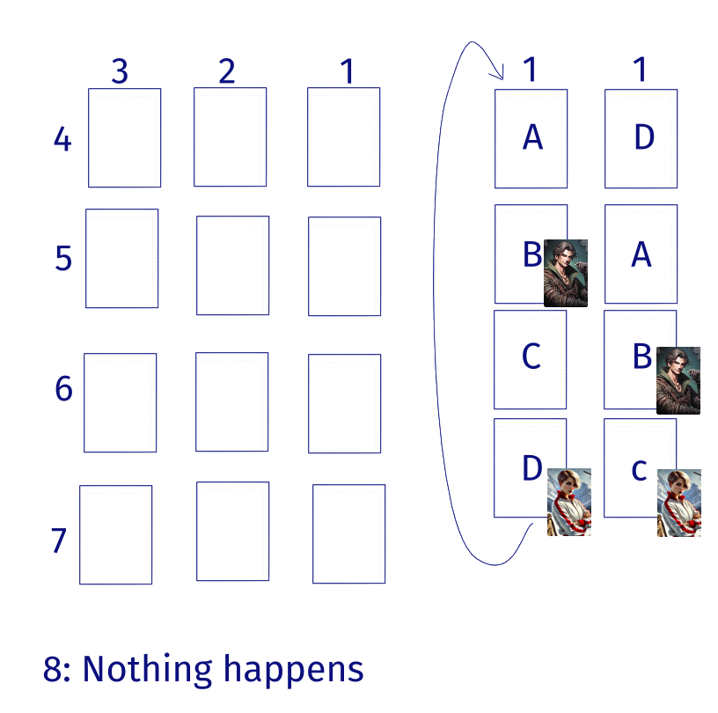
Investigators do not wrap around. Instead, they and enemies engaged with them, stay on their spot, entering their new location as if by moving. You can only be pushed right and down by this effect.
Any investigator on a moving location, stays on that location and no movement has occured.
You’re now ready to begin.

Scenario: Shadows in the Mist
Story that is totally cool.

Setup
B Do a thing.
B Then do another thing.
You’re now ready to begin.

Scenario: The Monestary
Story that is totally cool.

Setup
B Do a thing.
B Then do another thing.
You’re now ready to begin.

Scenario: The Vila
Story that is totally cool.

Setup
B Do a thing.
B Then do another thing.
You’re now ready to begin.

Scenario VI: The Farm
Story that is totally cool.

Setup
B Do a thing.
B Then do another thing.
You’re now ready to begin.

Scenario VII: Ladders and Snakes
Story that is totally cool.

Setup
B Do a thing.
B Then do another thing.
You’re now ready to begin.

Scenario VIII: Bloody Tears
Story that is totally cool.

Setup
B Do a thing.
B Then do another thing.
You’re now ready to begin.

Enemy: Dario

Enemy: Lucia

Enemy: Ludvig
In the sky above you, you see a faint purple shimmer. Like a malfunctioning northen light, but in a sickle twisted hue. Is that... is that a cultist chanting at a arcane sigil you see?
B Additional Setup:
Gather all cards from the Ludvig set.
B After putting locations into play, place Ludvig (Aspiring Arcanist side face-up) at the “Guard” location. Then place 4 of the 8 magic seals at the four locations with the highest shroud values.
B The rest of the cards are shuffled into the Day and Night decks respectively, as indicated by their backs.
B Return to the scenario setup. You may be instructed to return here to read codex entries while playing the scenario.

Enemy: Sophia

Enemy: Carmilla

Game Design
Hi there!
If you’re here before starting the campaign, you’re at the right spot. We’ll get right into what you can expect of major differences.

Experience as a self-adjusting reward
Contrary to other Arkham Horror campaigns, you’re generally not rewarded for doing well here. You do earn some experience for doing well and completing objectives, but a good chunk of the available experience, you earn by going out of your way and wasting time and resources on those points.
Victory points on locations and on enemies, are generally (75% of the time or so) a sign that you’re in the “wrong” place and that you can make faster progress by ignoring that enemy/location.
That said...

Story results
The story itself might turn out better or worse, depending on how you perform. It’s mostly about speed, as the introduction will tell you. But if you focus entirely on speed, you might not have the required experience to win later on.
You’re therefore in charge of determining if you need to slow down to have a better deck in the future, or rush ahead to get a better resolution to the story. This is not a campaign where getting ahead will snowball into an easy victory.

Difficulty
The difficulty is mostly self adjusting. The story depends on your results, and better results tends to also mean harder challenges. The normal “difficulty” that is chosen for every Arkham Horror campaign also exist here. Here, however, it’s not about the chaos bag, but about how well you need to perform, and how much xp you earn. Each scenario and card will instruct you when your difficulty matters.
Higher difficulties will have you do more for less.
B If you’re here before starting the campaign, this is where you head back, create some decks and visit the wonderful Walachia. We’ll see you back here after 8 scenarios.

Designer notes
In my defense, I did make 90% of this while on drugs.
In the defense of my defense, those drugs were all prescription drugs and makes me function closer to an average adult human person.

